NorthSeas Agile Peer Methodology

Stephen J. Parsons
President, CEO
NorthSeas Software, Inc.

©Copyright NorthSeas Software, Inc., 1999

For internal distribution only
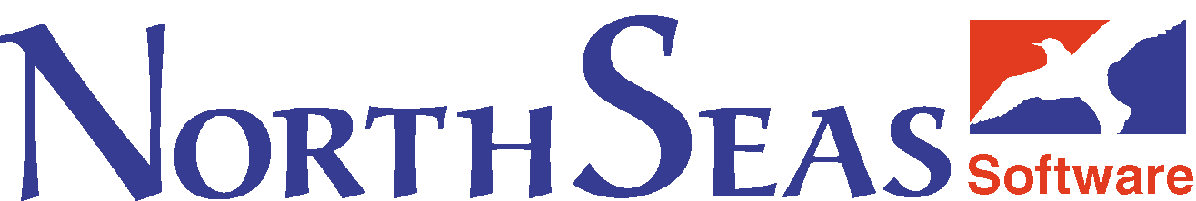

NorthSeas Agile Peer Methodology:

Overview:
The following document describes the details, methodologies, and supporting systems for NorthSeas Project Management and workflow model. NorthSeas management believes this model optimizes productivity, reduces redundancy, and supports the corporate mission. In addition, the plan will allow NorthSeas to leverage existing strengths and assets of the company and empower all members of the organization to perform as a cohesive team.

Objectives:

The objectives of this model are:

- to enhance productivity;
- to reduce redundancy;
- to create and identify opportunities and challenges;
- to enrich corporate culture;
- to empower all organizational members;
- to help provide accountability;
- to assist in coordinating production activities;
- to support the development of a team environment;
- to recognize and encourage achievement; and
- to develop both individual and corporate competency.

Methodologies and Fundamental Concepts

The implementation of the model is based on the following fundamental concepts, described in more detail below:

- Autonomous, Project-based Teams;
- Matrix approach to assignments (utilizing functional expertise);
- Open tasking rather than bureaucratic assignment;
- GUIDS methodology, the technology plan and KBMS;
- Whole team evaluation and contribution;
- Formal and Informal Professional Development;
- Bonus Opportunities; and
- Continuous Improvement.

Project-Based Teams

Work undertaken for NorthSeas clients (both internal and external) will be driven by project requirements. This methodology relies heavily on effective team collaboration. It will employ a matrix-style functional structure, implemented with the support of technical systems and tools such as MS-Outlook and on-line reporting through the corporate intranet. This level of teamwork empowers the operational staff to define, plan, and perform according to the requirements and constraints of each identified project.
Initially, team members are selected by team leaders (middle management) to fulfill the functional requirements of the project. Project Champions may be elected by the team and given autonomy to coordinate activities and to report to the Team Leader on progress, resource requirements (notwithstanding tasking – see below) and evaluative topics. Project champions will provide a weekly report on all projects under their care. Champions may be rotated within the team as appropriate according to their team’s preferences, capacities, and demands. Any available bonuses related to a given project (see Bonus Opportunities below) would be applied according to a process that combines peer and supervision evaluation. Evaluation of team members by both team leaders and peers will be incorporated into semi-annual (or more frequent) performance reviews. Accordingly, acceptance of such roles is totally voluntary. Projects under which teams are unable to meet consensus on project championship may elect to share championship tasks equally or to invite the team leader to accept the championship role. In such a case, the team leader will be a part of that project team and will share in the duties and the benefits of team membership. The team (regardless of its decisions on internal leadership) must undertake certain team functions, such as weekly reporting.

Consensus is a difficult but highly rewarding process that will encourage wider participation by all members. Consensus requirements are set on a project-by-project basis and will be totally autonomous to the team. The Team leader or Operations Manager as required can provide support and advice for all team processes.

Conflict is an expected part of this approach to project management. Conflict Management is one of the skills that must be developed within the team. Experienced teams tend to handle their own conflict issues more effectively than imposed resolution by upper management. Therefore, teams will be responsible for designing and implementing their own strategies for conflict management. The Team Leader or Operations Manager will offer support necessary to minimize and resolve conflict in teams, particularly in the early stages of the new Management model. Best practices are published on the corporate intranet.

Matrix Approach to Projects

The entire organization at NorthSeas functions as a team and all resources within that team should be available to all projects. As far as this project management model is concerned, there is no hierarchy in NorthSeas. Everyone in the organization is a resource and the project must drive the skill requirements. Accordingly, everyone will be available to contribute their skills to the project within their capacity. The reporting and responsibility, as defined by the corporate structure, drives the business model. Therefore, realistic capacities and job descriptions will help to identify availability of resources and the type and extent of contributions.
Typical Line-Staff Bureaucracy
Function
Project 1
Project 2
Project 3
Functional Matrix Structure
A matrix-approach creates the sense of a flat hierarchy, which is more fully explored under the “open tasking” topic below. In this approach, all team members are empowered to identify resources they require to fulfill assigned tasks. They should feel equally comfortable to assign or request resources within the matrix. It is critical that all team members appreciate that requested resources be appropriate (in terms of “cost”) for the level of effort required. Resources in the matrix should be considered for their functional expertise first, and then evaluated in terms of the cost to employ them to the project. Teams will be made aware of the project budget at the outset and will be expected to manage resources within that budget.

Open Tasking

NorthSeas will employ the Exchange Server/Outlook interface fully in the planning, implementation and reporting of task progress. Initially, Team Leaders - with the support of the Operations Manager and other resources - will identify tasks required to complete a project. These will be applied to a specific project code in MS-Project. The project team will be assigned the identified tasks, normally through an MS-Exchange Task assignment to the project champion who will work with the team members to sub-assign the tasks.
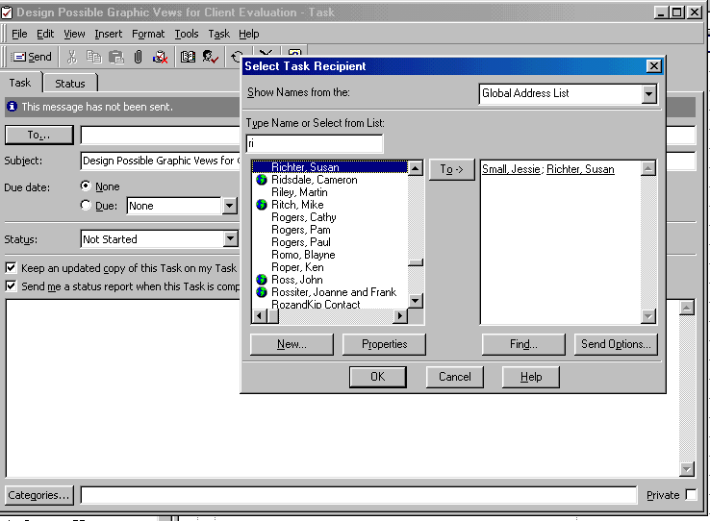
The initial task assignments are, intentionally, high-level and loosely defined. As team members receive assignments, they may recognize sub-tasks within these high-level requirements that are valuable or necessary to the performance of the task. In accordance with the foregoing sections any team member should, in the definition of their tasks, feel free to “task” any other member in the matrix, to provide resources to accomplish that task. To that end, team members are accountable to manage resources needed to fulfill task completion. If the task is at a level that is not easily defined, team members should task their project champion or team leader for further re-assignment.

To support this assignment process, a structure will be put in place to allow all staff to identify and register their skill sets in a corporate inventory that can be searched by all team members. Attached to the inventory will be a resource cost database to identify the “cost” assigned to a unit of any given employee’s time (based on salary, current demand, etc.). This inventory will be part of the Intranet application (currently in development). Staff will receive training on the effective use of Outlook for this application. A user guide for this purpose is available on the corporate intranet. This guide fully explains the process of task assignment within the team.

GUIDS Methodology, the Technology Plan, and KBMS

The management of the NorthSeas Software, Inc. believes that careful, systematic design is an essential prerequisite to the development of successful applications. In our experience, the investment pays off immediately by making the development and deployment more efficient. More importantly, it ensures better long-term results by improving user satisfaction with the resulting product.

To this end, NorthSeas uses the GUIDS methodology (articulated and popularized by Deborah Kurata and InStep Technologies) in project development, an iterative process that consists of the following phases:

- Goal-centered design. With the active participation of the project team, this step defines the elements needed to meet the system’s requirements and goals and details the scenarios of how the system will be used.
- User Interface design. Determines how the user will view and interact with the application, based on the scenarios defined in the previous step.
- Implementation-centered design. Defines the internal architecture and framework of the application and details how to apply the chosen technologies.
- Data design. Reviews the data associated with the application and defines the database structure.
- Strategies for construction. Defines approaches to be taken during the development phase of the application. This includes defining coding conventions and standards, source code control, testing strategies, and project planning and scheduling.

This methodology is implemented in a Microsoft binder template used for all application/ solution projects. A key function of the team’s initial planning involves filling out this section of the binder and presenting the GUIDS proposal to the team leader and/or Operations Manager.

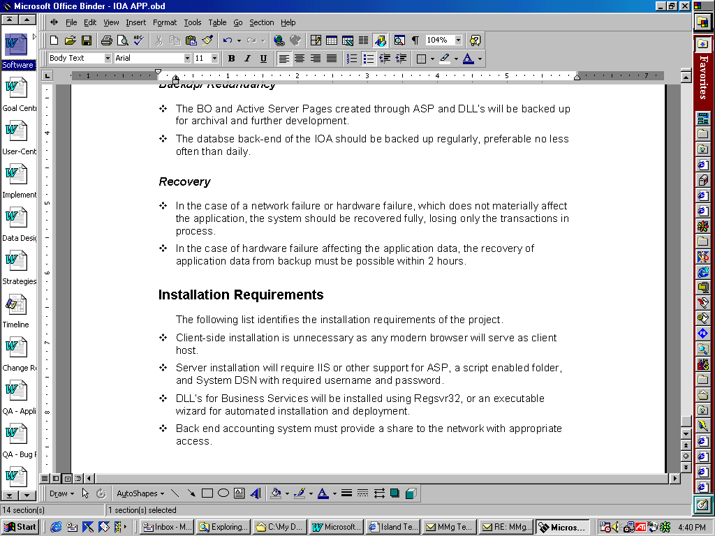
An amendment to the GUIDS process (under the first section- “Goal Oriented Design”) is the definition of a technology plan, which consists of the following key areas:

- Strategic
- Competitive
- Customer Satisfaction
- Investment
- Paradigmatic

For each of these key areas, there are a number of essential questions which must addressed as outlined in the following sections.

Strategic - What are the fundamental and constraining choices for the project solutions? What operating systems, servers, browsers or other systems will be supported or affected? What scripting languages will be used? What existing proprietary objects or code might be leveraged to provide a NorthSeas-owned and defensible position?

Competitive - Does this solution respond to or better a competitive strategy? What features of the solution identify competitive advantages?

Customer satisfaction -What specific customer needs does this solution address?

Investment - What specific features will be added to this solution that may not show up in meeting minimal project requirements, but rather set up an opportunity to leverage future incentives, opportunities, and benefits?

Paradigmatic - Does this solution change, in any measure, the way that people work or interact with solutions or interfaces of this kind?

The development and employment of the corporate intranet is crucial to this model. A critical component of the intranet application will be the implementation of a corporate “Knowledge Base Management System” or KBMS. The intent of this knowledge base is to protect, enhance, and better utilize the intellectual assets of the company. By archiving vital IP in a knowledge base, efficiency for project performance can be maximized by the provision and distribution of knowledge to the whole corporation. NorthSeas’ KBMS, code-named “Sophie”, is designed to allow for the archival and retrieval of code, documents, multimedia products, and web references (for things such as tutorials and technological literature).

Throughout the development of a project, teams will be conducting activities that include research & development, unique code development, and web searches. The products of these activities are made available to the organization through entry into the Knowledge Base. Team members can help reduce redundancy and inefficiency by searching the Knowledge Base for existing IP (and contributing new IP) to enhance project effectiveness.

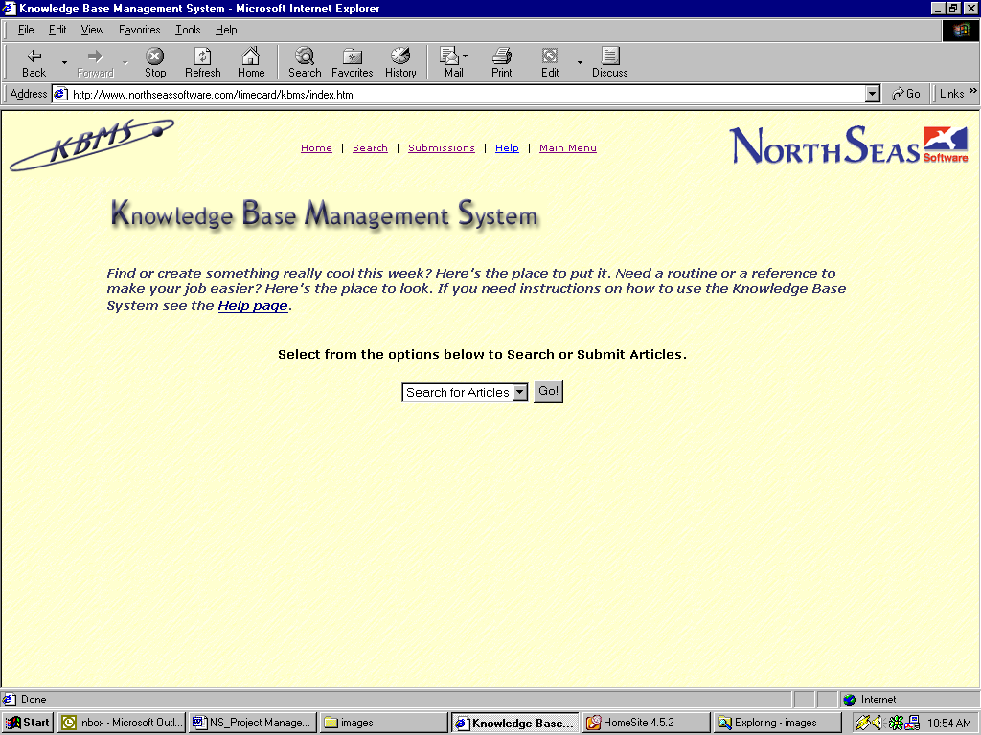
Sophie is currently installed on the NorthSeas server at: www.northseassoftware.com/TimeCard/kbms
The illustration at left shows a view from Sophie’s opening page. The search mechanism works in similar fashion such that team members can search on any of the relevant fields shown in this submission view. As the archive of IP grows, so will Sophie’s value to both the organization and its project teams.

Whole Team Evaluation & Contribution

NorthSeas’ HR policy manual identifies the need for regular constructive feedback to individuals and the organization. This ensures that a continuous process of QA is in place for the organization and its members as well as its projects. Project QA is maintained through regular, continuous and rigorous testing with error/bug reporting accomplished through the on-line Quality Assurance application in the corporate intranet. The illustration below shows a part of a Quality Assurance report.

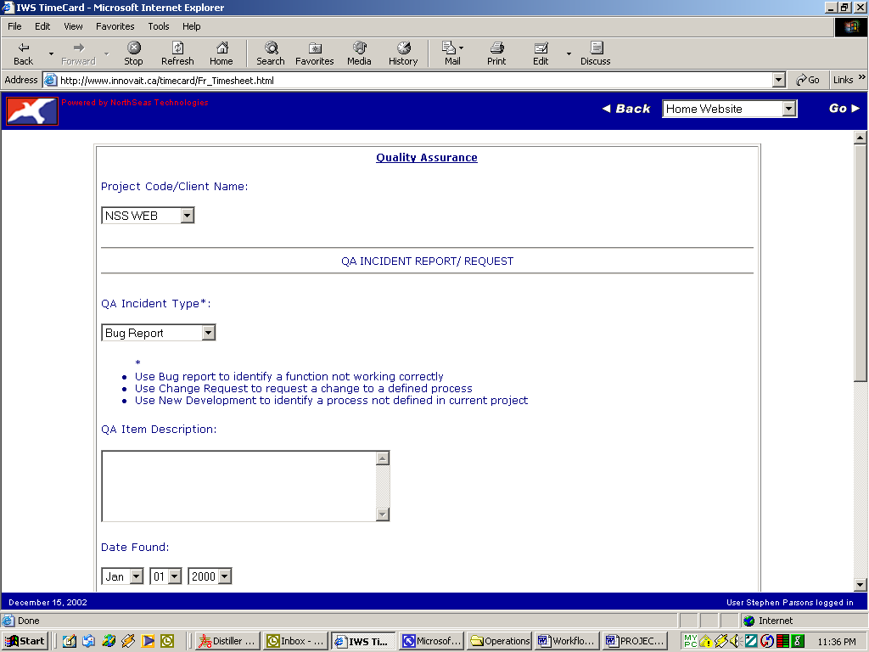

At the conclusion of each project, team members provide a full evaluation of the solution, including the effectiveness of the team processes, opportunities identified, and application performance. This project evaluation process also includes peer evaluation - used, in part, to determine the distribution of bonuses to team members (see Project Based Teams and the section below on Bonus Opportunities). A formula will be put in place to guarantee a minimum share to all team members and will include an incentive structure to reward outstanding performance.

In keeping with the objective of identifying opportunities and challenges, the evaluation process also solicits feedback and suggestions. Team members as well as project stakeholders (including the client) are encouraged to identify how a project solution could be effectively applied or adapted for future solutions. They are also asked for feedback on creating more effective team performance. The evaluation process will be implemented as a part of the corporate intranet and, therefore, will be available for completion on-line.

Professional Development

NorthSeas Software recognizes that survival in IT technologies is largely dependent on staying current in this highly dynamic industry. To support improved individual and corporate competency, this project management model will encourage identification and provision of PD opportunities. Professional Development policies are fully outlined in the HR manual; this model provides additional mechanisms for both formal and informal PD activities.

The evaluation process, as explained in the previous section, identifies challenges such as shortcomings in corporate inventory and personal development needs. Individuals are encouraged to identify suitable training opportunities to support their own development and career aspirations.

Moreover, the performance and structure of team projects should be planned to maximize informal professional development activities. This is achieved in a number of ways. For example, formal or informal “teach-backs” to the team or the organization may follow significant research and development initiatives; or experienced team members may be paired with less experienced individuals to offer a kind of apprenticeship to master developers. This is often difficult to achieve within inexperienced teams as they often become focused only on the immediate goals without considering the value that can be added to future projects and the enrichment of individuals. Therefore, it is essential for team members to be proactive on the issue of professional development and to incorporate it as part of the long-term planning process.

Bonus Opportunities

This project management model revolves around the themes of autonomy and empowerment for all members of the organization. For many projects, teams should be able to take advantage of bonus incentives that arise from two specific conditions.

The first of these occur when a team completes a project ahead of schedule and below budget. There need be contingencies to take care of those projects that will sometimes overrun the timeline and budget and for the financing of vital internal projects. However, additional profit generated from outstanding performance by a team should result in extra incentive and reward to the team in the form of a share of those additional profits. A schedule for this kind of bonus situation will be negotiated between the team and the team leader at the outset of each project.

A second source for bonus opportunities results from the negotiation of incentives between the marketing representatives and their clients. Many clients may be convinced to add bonuses for specific additional features or quicker turnaround on solutions. In such cases, the marketing representative may be included in the team with appropriate duties and benefits accruing to them.

As described earlier, team members will have a say in the share given to each member of the team (after the default minimum). This process of voting bonus shares helps in overall performance evaluation and creates motivation to produce excellence within the team environment. Upon completion of a project a special peer election form containing fields for each contributor (designed in VBA for Outlook) is circulated to each team member. The team member will enter the share of profit that he/she feels each member has earned in their performance on the project. Under normal circumstances 60%-75% of any bonus monies will be shared by team members based on their timesheet contribution. The balance is shared according to this peer election process.

Agility and Continuous Improvement

The methodology is a dynamic set of tools, techniques and methods that will need to grow and adapt over time to changing project needs, technologies, and team composition. In keeping with the autonomous nature of team self-direction, any part of this methodology can be adapted or omitted in the performance of a project, but any such adaptation or omission will require rationalization in the team’s initial report.

Annually or more often, the methodology itself will be subject to a QA review by a representative committee of developers, middle- and senior managers, clients, and (optionally) external consultants. This review will be facilitated by an external moderator who will be content agnostic, but experienced with process facilitation.

Summary

This project management model describes a methodology which - through its focus on peer empowerment and autonomy - provides a way to involve all team members in growing the company, assuring quality, and contributing to more efficient management of time and other resources. By offering an environment where individuals and teams are encouraged to develop creative solutions and modified processes, the Workflow Management model helps to make the company more competitive and effective. By including recognition for individual and team effort, the model supports personal growth and motivates achievement. These components help strengthen the organization in a competitive marketplace – and contribute to a positive internal working environment.

Appendix A – Project Review

Project Evaluation Form

The attached form is for the evaluation and review of projects conducted by NorthSeas Software, Inc. and its partners. This review process is a critical and valuable part of NorthSeas workflow model and Quality Assurance program and should be conducted for all projects regardless of size and nature. The review process involves evaluation of three key areas of performance and workflow – a) Working Relationships and Team Performance, b) Vertical Markets, Opportunities and Challenges, and c) Proof of Concept/ Application. A separate form may be appended as an option to provide client feedback on specific client satisfaction and concerns.

The data from this review will be collected and compiled into a detailed report for internal use and a summary report for external partners and stakeholders. All information submitted is confidential and is not to be released to third parties without the express permission of NorthSeas Software, Inc.

Thank you for agreeing to participate in this review.
PROJECT EVALUATION

Date: ________________ Project Title/Client:______________________
Evaluation conducted by: _________________________________________________
Instructions: Indicate your level of satisfaction in each identified area by circling a number to select a rank according to the following scale:
1=Poor 2=Unsatisfactory 3=Satisfactory 4=Good 5=Excellent
Provide any additional comments in the space provided or on the back of the sheet.

PART 1: WORKING RELATIONSHIPS & TEAM PERFORMANCE

How satisfactory was your level of involvement in this project? | 1 | 2 | 3 | 4 | 5
Comments:

How effective was the team performance? | 1 | 2 | 3 | 4 | 5
Comments:

How effective was the team leadership? | 1 | 2 | 3 | 4 | 5
Comments:

What do you feel would improve similar team-based projects?
Comments:

PART 2: VERTICALS, OPPORTUNITIES AND CHALLENGES

How effective was this project in solving client problems? | 1 | 2 | 3 | 4 | 5
Comments:

How effective was this project in identifying new opportunities? | 1 | 2 | 3 | 4 | 5
Comments:

How effective was this project in using available technologies? | 1 | 2 | 3 | 4 | 5
Comments:

Were delays, conflicts and other challenges addressed promptly and appropriately? | 1 | 2 | 3 | 4 | 5
Comments:

Describe any opportunities and/or challenges identified from this project.
Comments:

PART 3: PROOF OF CONCEPT/APPLICATION
Using the following scale, evaluate the project solution on each of the given elements.
1=Not at All 2=Unsatisfactorily 3=Satisfactorily 4=Very Well 5=Excellently
Provide any additional comments in the space provided or on the back of the sheet.

Solution meets established goals and objectives. | 1 | 2 | 3 | 4 | 5
Comments:

Solution uses appropriate technologies, language and methods. | 1 | 2 | 3 | 4 | 5
Comments:

Solution easily integrates into system specifications. | 1 | 2 | 3 | 4 | 5
Comments:

Solution can be encapsulated to make it proprietary. | 1 | 2 | 3 | 4 | 5
Comments:

Solution, or its components, can be reused or adapted to more general purposes. | 1 | 2 | 3 | 4 | 5
Comments:

Solution provides opportunities for partnerships and exposure. | 1 | 2 | 3 | 4 | 5
Comments:

Solution offers marketable opportunities. | 1 | 2 | 3 | 4 | 5
Comments:

Solution can be patented or otherwise protected. | 1 | 2 | 3 | 4 | 5
Comments:

Solution uses appropriate dynamic data access. | 1 | 2 | 3 | 4 | 5
Comments:

Describe any concept or application issues identified in the delivery and presentation of this solution.
Comments:

Provide any additional comments on this project:

For reference on technology plan check out Dynamics of Software Development, Jim McCarthy (Microsoft Press) – available in the NorthSeas library
This location changed to www.innovait.ca/timecard following the closure of NorthSeas R&D division.
A copy of the full project evaluation form appears in Appendix A.

